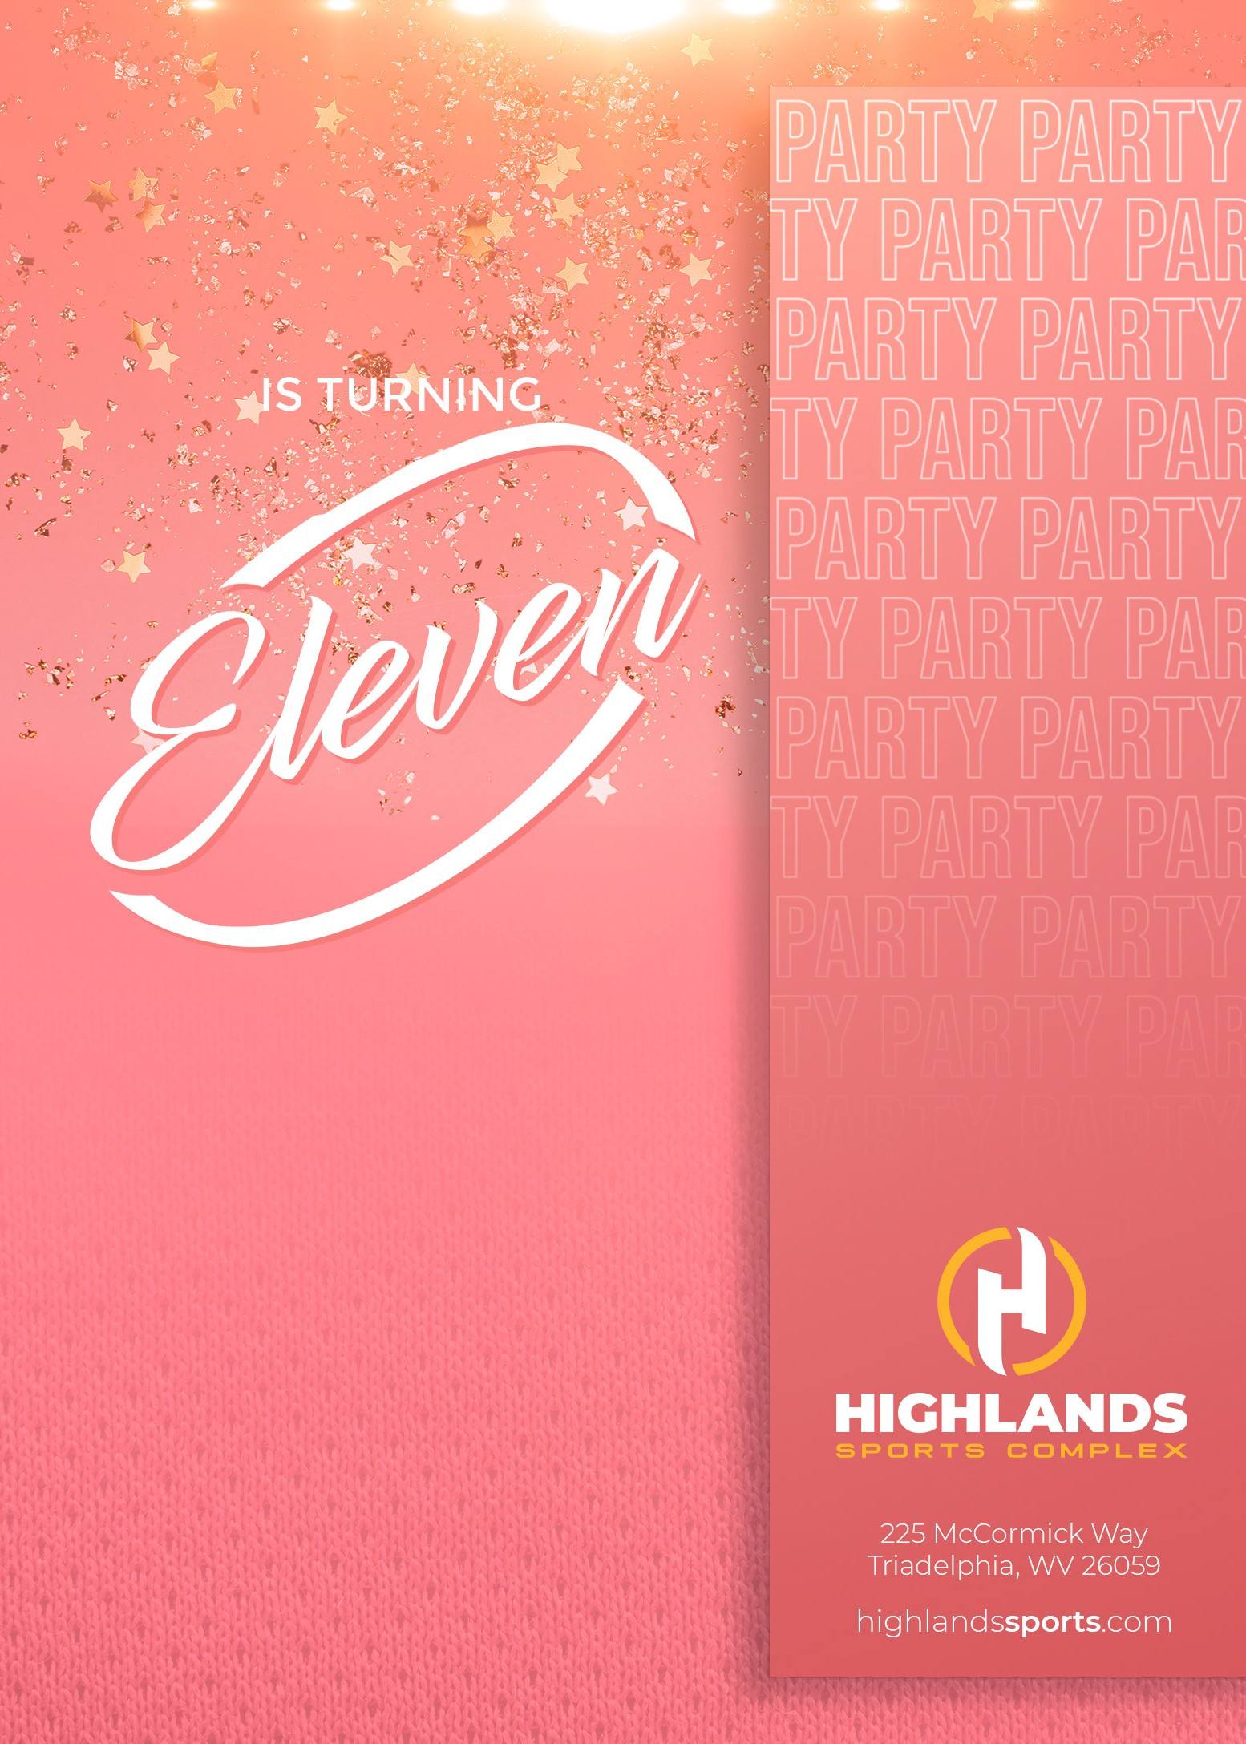
SUZY SMITH

Join us for an
AWESOME PARTY
SATURDAY, JANUARY 8 2PM - 4PM

RSVP TO SUZY’S MOM 555-123-4567
BY JANUARY 1

